Approaching Perpetua

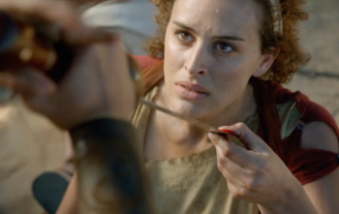 | 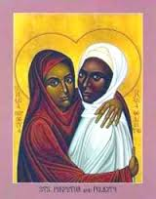 | 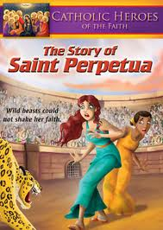
www.mymultiplesclerosis.co.uk/history www.catholicvideo.com
- From Thecla to Perpetua
- De facto toleration and occasional terror
- Church in the Empire
- Montanism or Moderation
- Power and Gender
- To the Text

___________________________________________________________________________________
Arjava, A. Women and Law in Late Antiquity. Oxford U. Press, 1996.
Barnes, T.D. Early Christian Hagiography and Roman History. Tubingen: Mohr Siebeck, 2010.
Cox Miller, P. Dreams in Late Antiquity… Princeton U. Press, 1994.
Castelli, Elizabeth. Martyrdom and Memory: Early Christian Culture Making. N.Y.: Columbia U. Press, 2007.
Darling, R.Y. In Procession Before the World: Martyrdom as Public Liturgy in Early Christianity. Marquette, 2001.
Heffernan, Thomas J. The Passion of Perpetua and Felicity. Oxford U. Press, 2012.
Robeck, C.M. Prophecy in Carthage: Perpetua, Tertullian, and Cyprian. Cleveland: Pilgrim Press, 1992.
Salisbury, Joyce E. Perpetua & Passion: the Death and Memory of a Young Roman Woman. Routledge, 1997.
Shaw, D.B. “The Passion of Perpetua.” Past & Present no. 139 (May, 1993), pp. 3-45.
Streete, Gail P.C. Redeemed Bodies : Women Martyrs in Early Christianity. Westminster/John Knox 2009.
Tabbernee, W. “To Pardon or Not to Pardon? North African Montanism and the Forgiveness of Sins.” Studia Patristica 36 (2001): 375-386.
Trevett,Christine. Montanism:Gender, Authority and the New Prophecy. Cambridge U. Press, 1996.

www.tertullian.org
ksawyer@mccormick.edu

